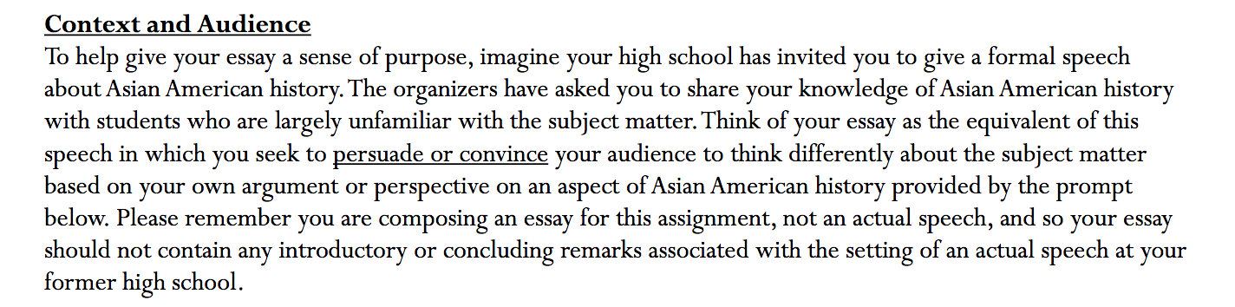
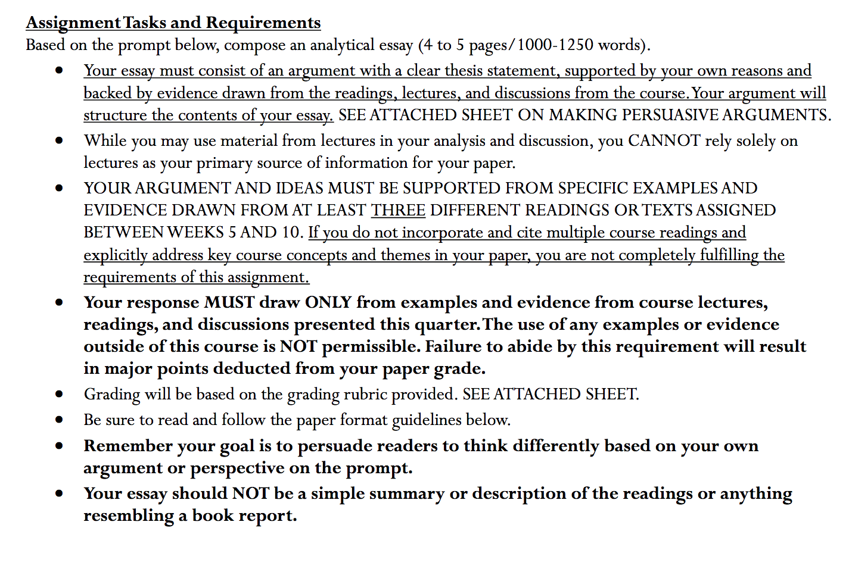
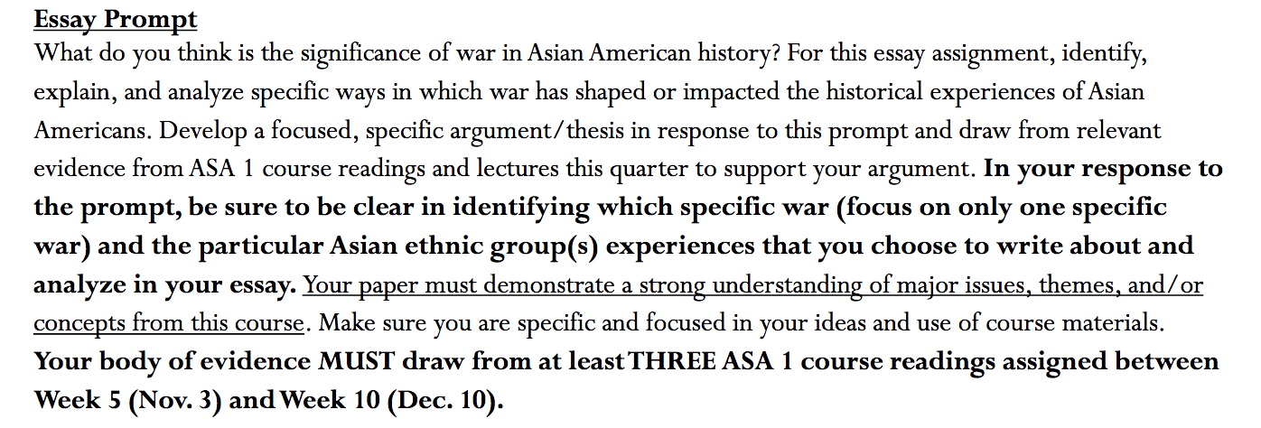

You are NOT SUMMARIZING. THIS IS AN ARGUMENTATIVE PAPER, WHERE YOU GIVE YOUR ARGUMENT AND CLEAR THESIS BASED ON THREE DIFFERENT COURSE READINGS. PLEASE READ!
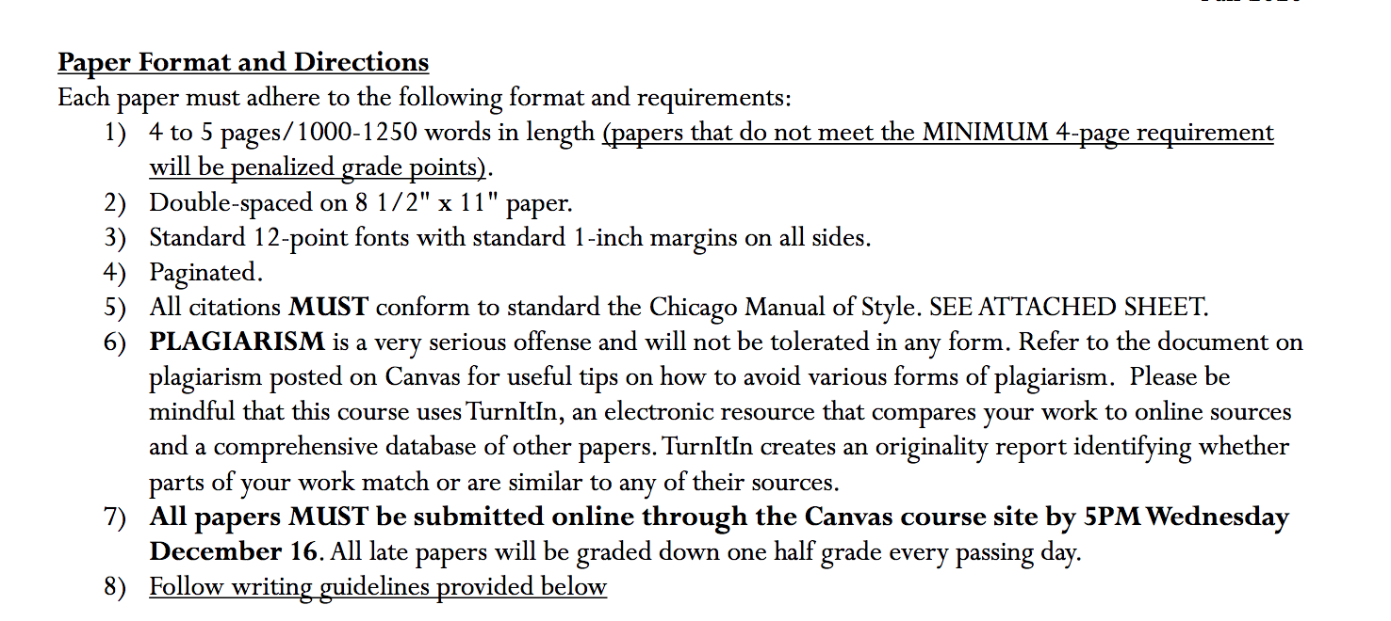

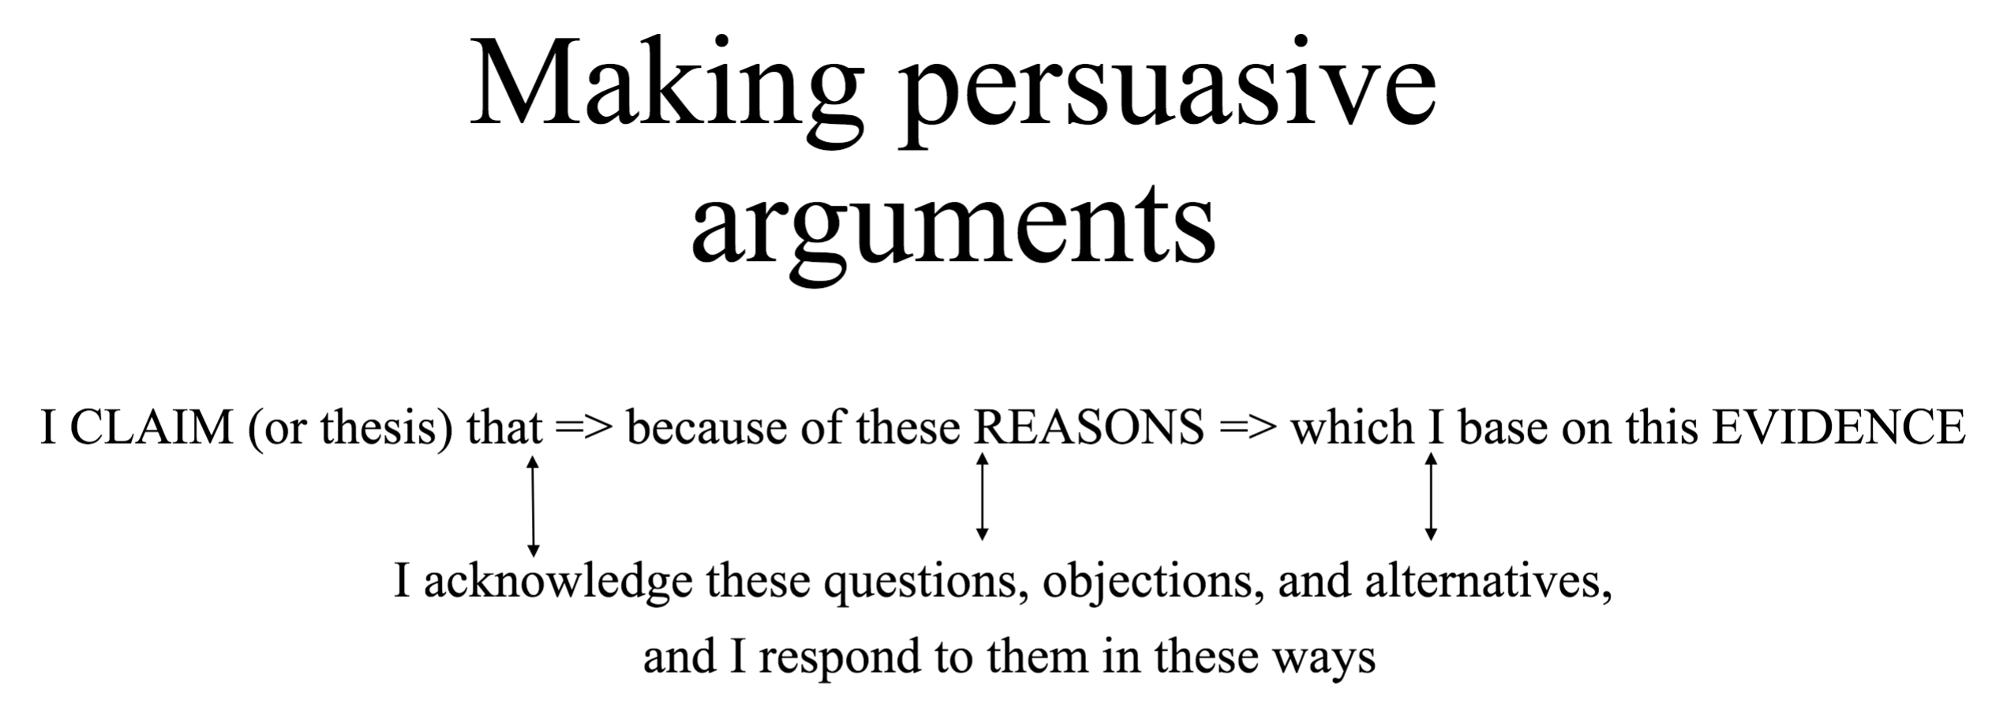

Your body of evidence must draw from at least THREE course reading assigned below!

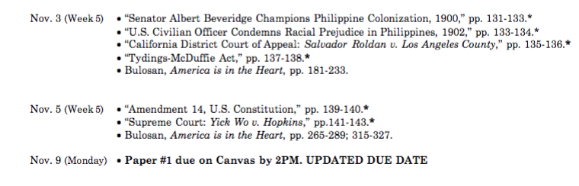

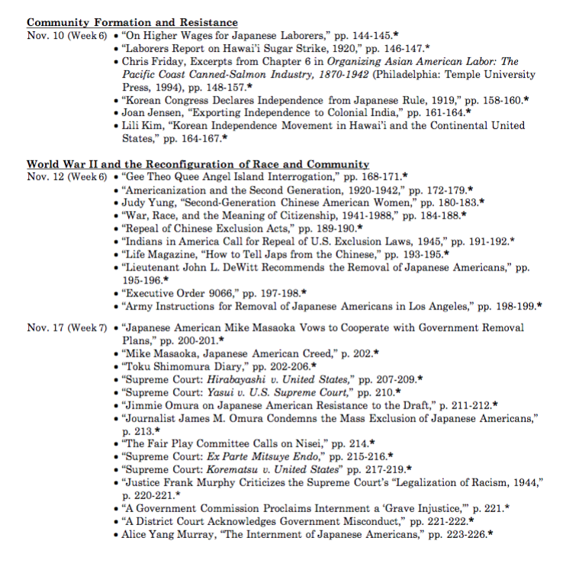

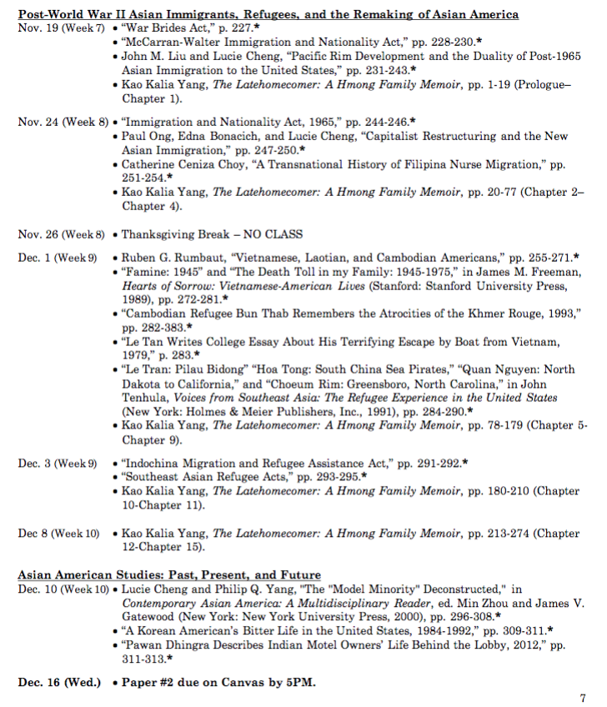

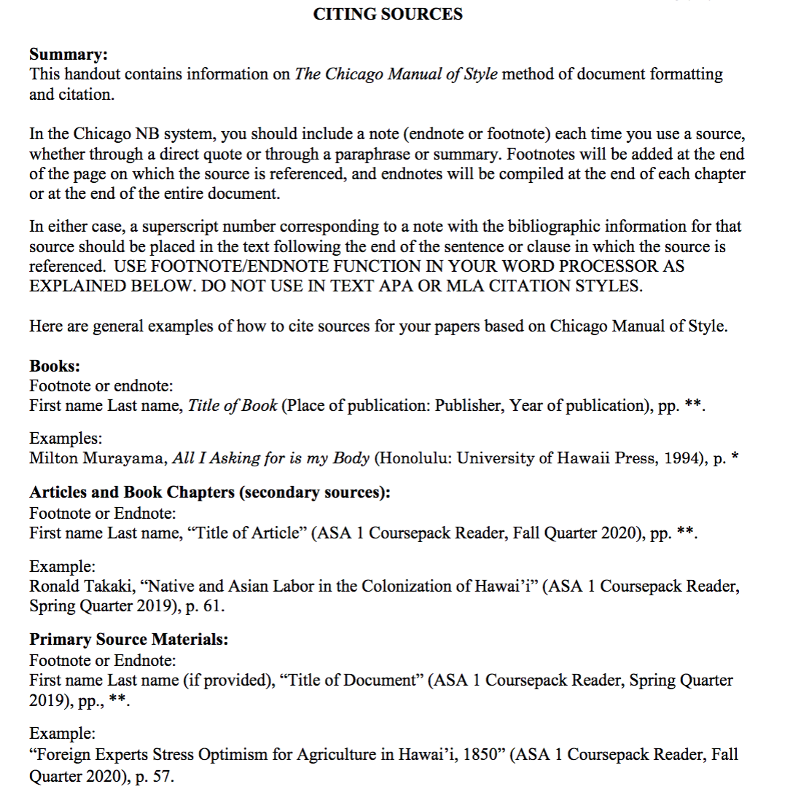

Please talk about WW2, see the example below!

I will give you some examples to give you the concept or ideas of doing this assignment. You can take this paper's ideas. It was the work of a student who took this class last quarter. Please see how he does it. I take this file from “Course Hero”. You can paraphrase it to avoid Plagiarism because my professor will use “TurnItIn”. Also, please read “how to cite the source” and “how to make a persuasive argument” above. Please also read the last prompt’ feedback. There will be one more short writing assignment that I will upload later.

THIS IS A VERY GOOD EXAMPLE THAT YOU CAN FOLLOW:

Big Turning Point in Diversity of Asian American Post 1965
America is known as a land of opportunities and shelters of many Asian originally from many nationalities. Each individual came here looking for a better life, a better education, or a better political right and economic elites. “World War II had a profound impact on Asian American views of colonialism, nationalism, patriotism, democracy and citizenship” (Chan, 189). As a result, after World War II, there were huge major changes in Asian American and Asian countries communities in recovering and reconstructing the geopolitical as well as economy and overall size of countries structures. Compare to time during and before World War, the Post 1965 period marked a turning point in diversity of Asian American society. This time had dramatically increasing in Asian American population’s diversity made up by large number of migration result of flexible U.S Immigration Act in 1965, the contribution of professional middle classes from developed industrial countries, and the large-scale of Indochinese refugees away from their countries’ war.
Unlike the immigration act in 1924 before World War II, the Immigration and Nationality Act, October 3, 1965 created an impact in inducing significantly the migrations from Asian lead to varieties in Asian American diversity. This act “is directly responsible for dramatic growth in Asian American Communities” (Chan, 247). This law allowed 20,000 immigrants from each country in Eastern Hemisphere, and total cap is 170,000 per year (Chan, 247). Depend on how close in relationship with U.S citizens, their relatives could migrate legally to U.S and became U.S citizens. For example, in the fourth reference of the act, married sons and daughter of citizens could be eligible to move to America and had chance to become U.S citizens (Chan, 247). Later, when they had stable lives here and have ability to sponsor to any of their spouses back to their countries. These people could become U.S citizens and sponsor for the next generations. This leaded to the hybridization of nationalities and with other ethnicities and resulting in diversity of population. Before World War II, most Japanese, Korean, Chinese and Filipino immigrants to U.S was strict in qualification to earn legal permissions enter U.S because of Immigration Act 1924. In the National Origin Act: An act to limit the Immigration of Aliens Into the United States, and Other Purpose, 1924, they excluded Asian and Pacific people and restricted large amount of people originally from Southern and Central/Eastern Europe (Chan, 124). For examples, the Filipinos could not have ability to earn citizenship status and restricted to enter the U.S. However, after 1965, “high growth rate” of Filipinos could legally move to the U.S and demand for the U.S citizenship. Thus, The migration Act in 1965 made a big turning point in large-scale population of Asian American population history.
After 1965, professional people in middle classes from development of capitalist ideology countries moved to America lead to big turning point of Asian American diversity. Before World War II, the major of people move to America including Chinese, Korean, Filipino, Asian Indian, and Japanese with largely number of farmer between1850-1924. Large major of peasants migrated here with hoping to have better lives, better educations because they lost their lands which were preserved for generation due to high taxation. However, after World War II, Asian American added in major high skills groups from Taiwan, Hong Kong, South Korea, and Philippine. The rapid develop in the industrial growth in many East Asian nation shifted to the urbanization process and create major of high skilled and talented people. (Liu and Cheng, 236). Beside, these lead to the overpopulation and deteriorating environmental and competitive in practice their professional,thus, some people remained unemployed. The ambitious wishes to perform and expand their professional skills with the relaxation of Immigration law in 1965 mark the decision to migrate to America, a land of opportunities. “Asian graduates are becoming a significant portion of skilled occupational force in the United State” (Liu and Cheng, 238). In additional, U.S also sponsored excellent student (pensionados) to United Sates to study in college and university. Before World War II, between 1910 and 1938, these pensionados were self-supporting students followed their ancient to U.S without supporting in education. They could not even claim human rights and work under table salary, thus, it was tough to work pay for tuition and maintain study as same time. Later in 1965, under support of U.S for citizenship and social benefits, they could afford education and become professional labors in U.S. Filipinos students had two categories, the first major was domestic labor market and underemployment and other major was student exchanges or as emigrants. Between 1966 and 1970, 17,134 Filipino professional emigrated to United State including engineers, scientist, and physician as well as nurses (Chan, 256). This period time was big turning point of diversity of Filipinos in particular. They finally majored part of business, civic, government systems in U.S. Compare with Filipinos after Korea war (1950-1953), South Korea won over communist North Korea and benefited from special international relation with U.S. Many famous and big institutions established in Korea by U.S program. Many students had high education in Korea also had obstacles demanding jobs after graduating (Liu and Cheng, 239). Thus, American was their point to reach their dreams having chance to practice their professionals. About “seven thousand educated South Korean depart to United State and fewer than one thousand returned” (Liu and Cheng, 239). Base on this data, we could conclude that high educated South Korean students moved to United and make up a major Asian American diversity this time. Before 1965, most of Korean labor in laundry and agriculture, but after 1965, Korean communities had different level from labor to professionals. Same as South Korea and Philippine, Taiwan had a large number of graduates from high education college facing a situation demand for job (Liu and Cheng, 239). This was tough for spaces and employment. English was secondary education put in Taiwan and thus, United Stated was an object that these students wanted to pursue. “By 1987, more than one –third of NTU’s- National Taiwan University faculty members had received their highest degree from U.S institution”, (Liu and Cheng, 240). These exchange and program led to a new movement of Taiwanese students to America and mostly stayed here. Together, professional and talented people from these three countries resulting in a new big Asian American community made a difference in diversity of Asian American.
After World War II, major of refugees from Vietnam, Lao, Cambodia made up big distinguish changes in Asian American diversity. Vietnam war (1945-1975), Lao war 1960s and “killing field” in Cambodia 1970s resulted “one million refugees and immigrant from Vietnam, Cambodia, and Lao arrived to the United States.” (Ruben Rumbaut, 258). These people were provided with legal political entry status to America. Before 1965, the Laotian, Cambodian, Vietnamese did not make a major in Asian American community and about fewer than 20 total people immigrant from Lao, Vietnam and Cambodia around 1952. However, after 1965 period, they were big slice in pie of Asian American society. The reported show that as late 1969, fewer than 200 Cambodian and Laotian immigrants were admitted and more than 3,000 including university from elite families as well as diplomats and brides who were sponsored the U.S soldiers during the war in Vietnam in late 1960s. In April 1975, the war of North and South Vietnam and the communist took over the Vietnam by Viet Cong. The Sai Gon-central of the South Vietnam fell, about 130,000 refugees found way to America and the only transportations were boats. (Ruben G. Rumbaurt, 261). For example, Quan Nguyen, as a Vietnamese refugee, left Vietnam in 1975 with an expectation that America could take care of him for few years. America could take care of him Cambodian who survived in the “killing field”, and preliterate swidden farmer in Northern Lao could be resettled in United States. These are called Indochinese refugees and got help from America. These people came here legally, so they could become legal citizen and were provided by government assistances with healthcare, food, shelter, and social security. To conclude, the migration of Indochinese refugee events was an impressive historical event of creation a large number of Vietnamese, Laotian, and Cambodian American.
Together, three above explanations for diversity in Asian American society clarify the turning point of Asian American’s diversity after World War II post 1965. Japanese, Korean, Chinese, Asian Indian, Indochinese and other groups had their different reasons, different ways, and different aims when coming to America. They are known as group of Asian Americans with different ethnicity, education, skills, classes and nationality. The major migration of this time period was a remarkable point in Asian American history. As time fly, the generations follow generations and hybridization between ethnicity creates a high diversity of communities in America. However, the generations still conserve their cultures and proud history so that the younger generation could look back and learn their history.
Word Cited
Chan, Sucheng. Chapter 9 “War, Race, and the Meaning of Citizenship 1941-1988”, Asian American: An interpretive History. Twayne Publiser 1991. 198
John M.Liu and Lucie Cheng. Chapter 4. “Pacific Rim Developement and the Duality of Post-1965 Asian Immigration to the United States”. Asian American: An Interpretive History. Twayne Publisher 1991. 234-244.
Chan, Sucheng. Chapter 5. “Immigration and Nationality Act, October 3, 1965”. Asian American: An Interpretive History. Twayne Publishers, 1991. 247-256

Ruben G. Rumbaurt. Chapter 6. “Vietnamese, Laotian, and Cambodian Americans”. Asian American: An interpretive History. Twayne Publisers, 1991. 258-261.
Chan Sucheng, Chapter 18. “The Death Toll in My Familly 1945-1975”. Asian American: An interpretive History. Twayne Publiser, 1991. 291

